Name:
Date: |  | I am on a mac computer €
My Achievement Goal for this chapter is… (Circle one)
A+ A B C D
(Teacher only) This assignment….
Is Good to go € | Needs Corrections:
Make sure that you show all of your work!
- You measured your floor to be about 15m², but the flooring company only provides quotes in ft². Without having to re-measure, what is the area of your floor in square feet to the nearest foot?
1m= 3.28 ft
1 m² = 10.76 ft²
15m² =?
15x10.76=
- If you shrunk the following image by a scale factor of .05, what would the new area be?
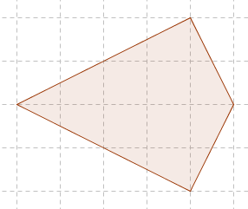
Shrunk area= original area x scale factor
Complete squares are 4
Half-squares are=12
Total= 4 + (12 x 1/2) = 10 cm²
Shrunk area= 10x 0.5= 5 cm²
- You are a surveyor and took a picture of a property from directly overhead. The area of the property is 1.37 square kilometers. The area of the property on the printed photograph is 18.71 square inches. What is the scale factor?
Scale factor = Printed area/the area of real object
1km² = 1550003100 sq. in
1.37 =?
1550003100 x1.37= 2123504247 sq. in
Scale factor =2123504247/ 18.71 = 113,495,684.

- How many cubes would be needed to build an object that is similar to the one below but scaled by a factor of 9?
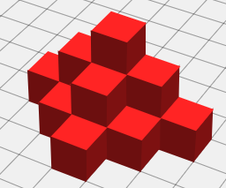 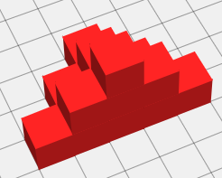
The new number of cubes= number of initial cubes x square of scale factor
=14 x 9²=14x81=1134 cubes

- You are a baker obsessed with fairness. You make a cake that has the following dimensions that sells for $7.00. If you wanted to price based on volume of cake, and were to make a larger cake that is scaled by a factor of 2, what should you charge?
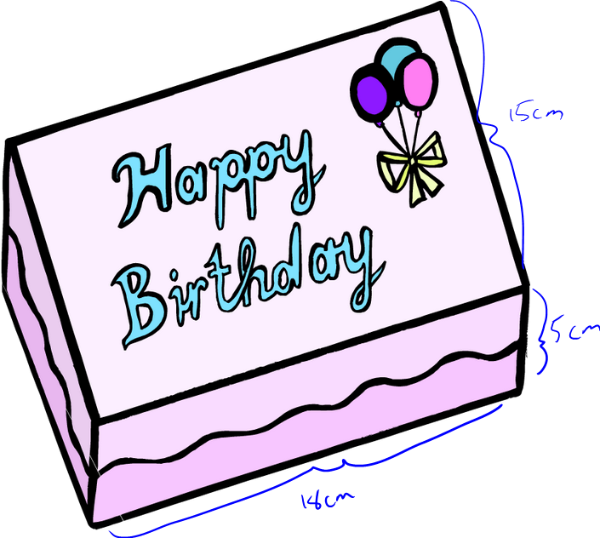
Volume of the cake=L x W x H
18cmx15cmx5cm=1350 cm²
New volume of cake=initial volume x squared scale factor
1350cm² x (2²) = 5400 cm²
1350 cm² = $7
5400 cm² =?
(5400 /1350) x 7= $28

